Removing and Reseating the Drum Cartridges on the Dell 5130cn Printer
1. Turn the printer off.
2. Open the front cover.
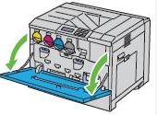
3. Rotate the lock levers of the inner cover to open it.
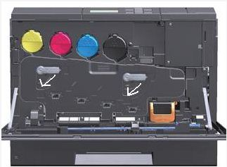
4.Grasp the handles on the drum cartridge you want to replace and pull out the cartridge halfway.
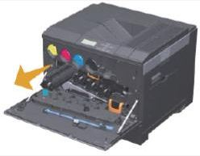

5. Grasp one side of the drum cartridge with the other hand and pull out the cartridge from the printer.
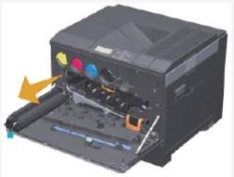
6. If this is a new drum cartridge, pull out the ribbons.
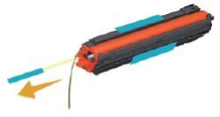
7. Slide the cartridge into the slot.
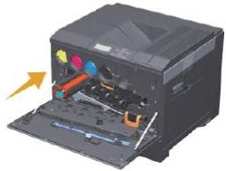

8. Remove the orange protective covering (if present) of the installed drum cartridge and discard.
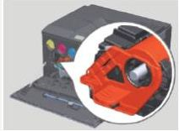
9. Close the inner cover.
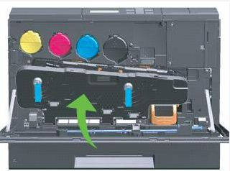
10. Rotate the lock levers to secure the cover (Figure 9).
11. Close the front cover.

